If you take a CPR course from the American Red Cross or the American Heart Association you will find the content to be nearly identical. However, the two organizations have noticeably different recommendations on how to respond to a child or adult who is conscious and choking. What follows is a brief history of the recommended responses to conscious choking - a history that has been filled with controversy for nearly the last 40 years.

When first aid courses began being taught to the public, the conventional response to a choking victim was to give them a "back blow" or "back slap".

As early as 1933 the American Red Cross was recommending this method. You can see an example of traditional back slaps in the film, "Field of Dreams" when Burt Lancaster's character, a doctor from the 1920s, saves a choking child.

* Place the toddler on a flat surface, face upwards.
* Cover the toddler's mouth with your mouth.

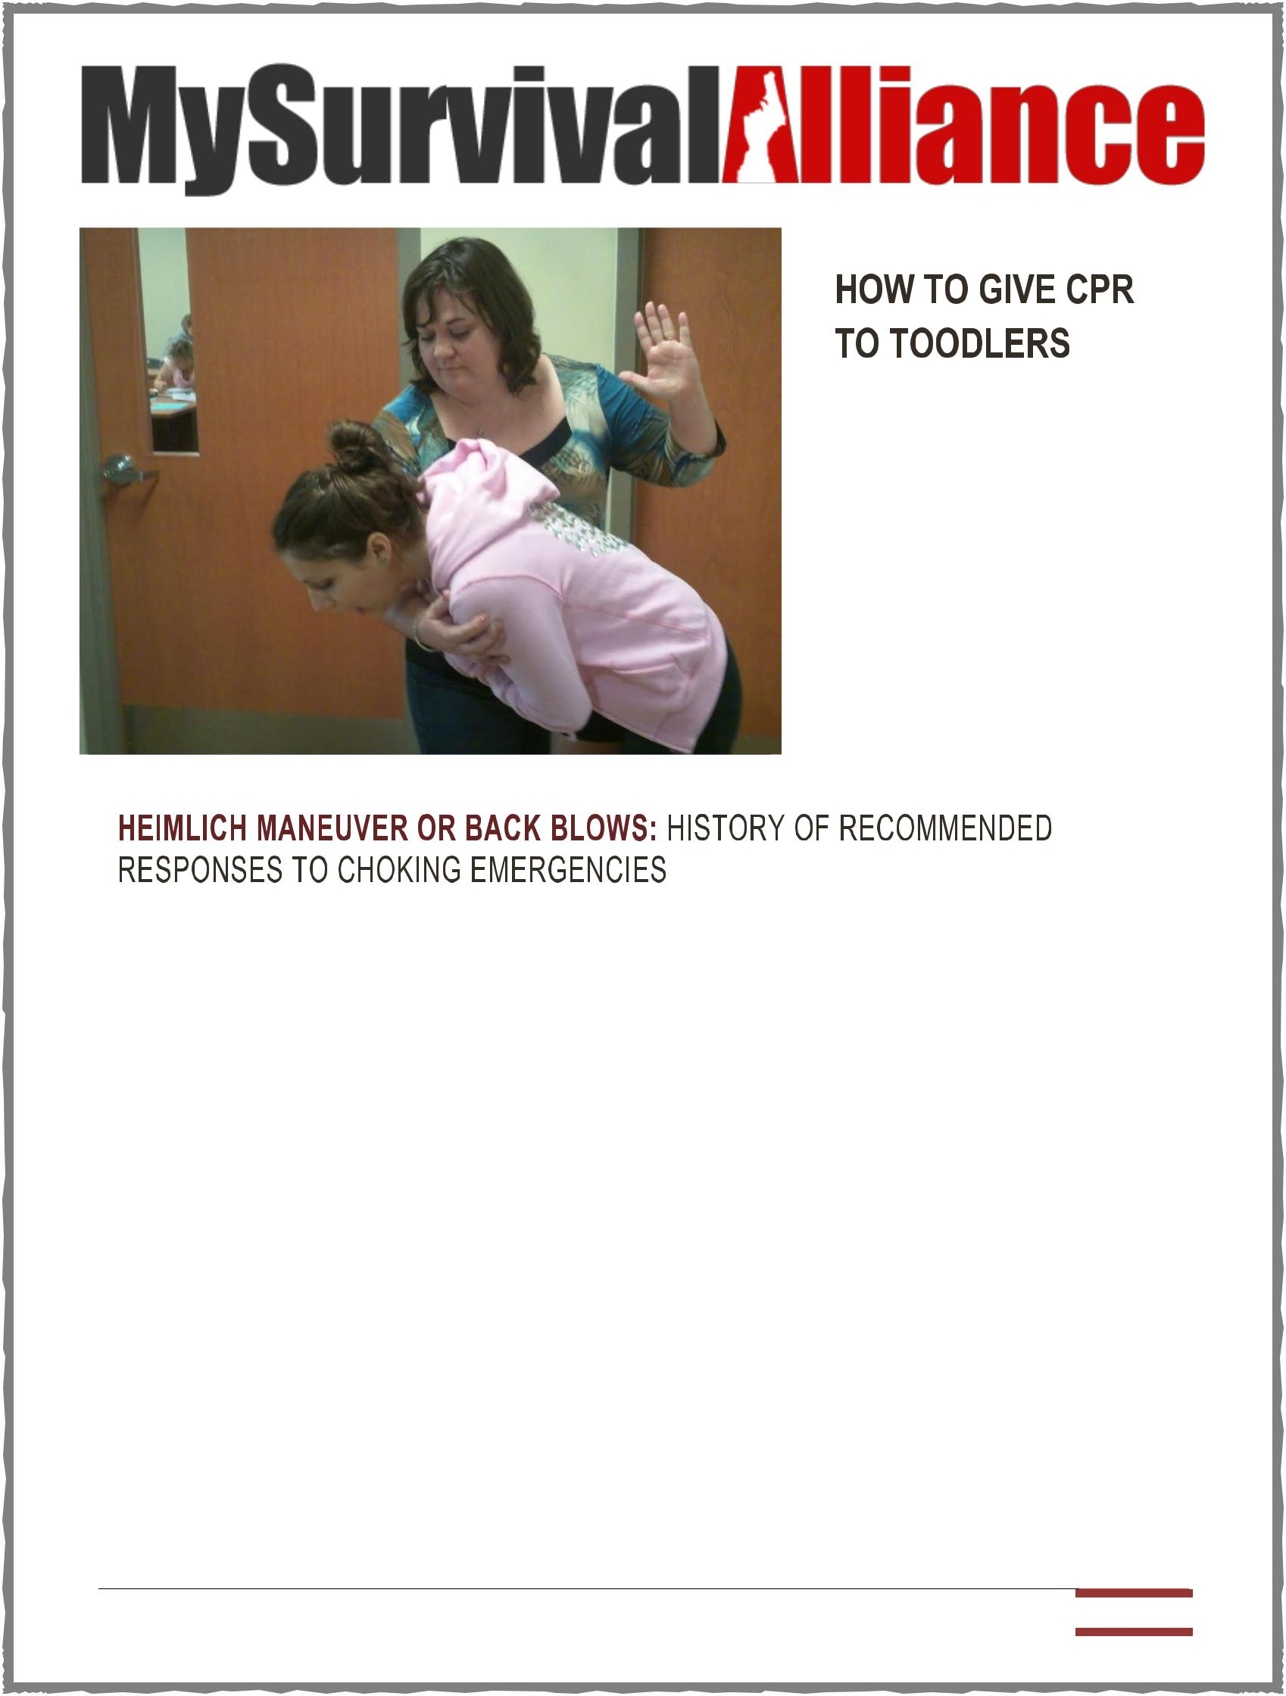

.. Continue Inside

In 1974 everything changed. Dr. Henry Heimlich, who developed the Heimlich maneuver, often called abdominal thrusts in safety classes, published an article about the maneuver.

By 1976 both the American Heart Association and the American Red Cross had incorporated abdominal thrusts. Responders were told to give back blows, but if they failed to dislodge the object, give abdominal thrusts.

Heimlich wrote in the New York Times that back blows would cause an object to get lodged into the windpipe. This has never been proven scientifically. He also called them, "death blows."

In 1986, both organizations stopped recommending back blows. Abdominal thrusts became the only recommended response for conscious choking for children and adults.

My Survival Alliance | Volume #4 | Issue #6 Page: 1 

Controversy and criticism of Dr. Heimlich began to emerge, much of it via his son Peter. Peter Heimlich has a website devoted to exposing his father as "a spectacular con man and serial liar."

Dr. Heimlich was accused of secretly funding a study in 1982 that persuaded the American Heart Association to drop back blows from its recommended responses to choking.

Nevertheless, abdominal thrusts remained the only recommended response to conscious choking for children and adults for twenty years.

In 2006, the American Red Cross reintroduced back blows as the initial response to choking. The approach is called, "five and five." If five back blows are unsuccessful in clearing the airway, then five abdominal thrusts are used.

The rescuer alternates between sets of back blows and abdominal thrusts until the object is cleared. However, the American Heart Association has not reintroduced back blows.

They continue to recommend abdominal thrusts as the only response to conscious choking for children and adults.

Chris Schlesinger's company In Home CPR offers CPR, BLS, AED, standard first aid and pediatric first aid certifications through the American Heart Association and American Red Cross.

He teaches classes at homes and businesses throughout the San Francisco Bay Area, serving the counties of Marin, Sonoma, Napa, Contra Costa, Alameda, San Mateo, Santa Clara and Solano.

**Canning Honey Sweetened Strawberry Limeade and Strawberry Lemonade**



*Ingredients (makes approximately 3 ½ pints)*

* *4 cups strawberries, hulls removed*
* *water*
* *1 cup fresh lemon or lime juice*
* *¼-1/2 cup honey*

*Special equipment*

* *Strainer (fine mesh strainer or strainer with a coffee filter)*
* *Canning equipment*

*Preparations:*

1. *Place the strawberries in a large pot. Add enough water to just barely cover the strawberries.*
2. *Boil the strawberries for 5 minutes or until the strawberries turn from red to pale pink.*
3. *Strain the berries out of the juice with a fine mesh strainer or a strainer lined with a coffee filter.*
4. *Add the berry juice and lemon/lime juice to a large pot.*
5. *Add the honey. When adding the honey start off with a smaller amount and taste your juice before adding more keeping in mind that you are tasting concentrate.*
6. *Bring the concentrate to a boil.*
7. *Add the juice to hot, sterile jars leaving ¼” headspace.*
8. *Place lids that have been simmering in hot water on the jars. Screw on the second part of lid.*
9. *Process for 15 minutes in a boiling water canner.*

My Survival Alliance | Volume #4 | Issue #6 Page: 2 

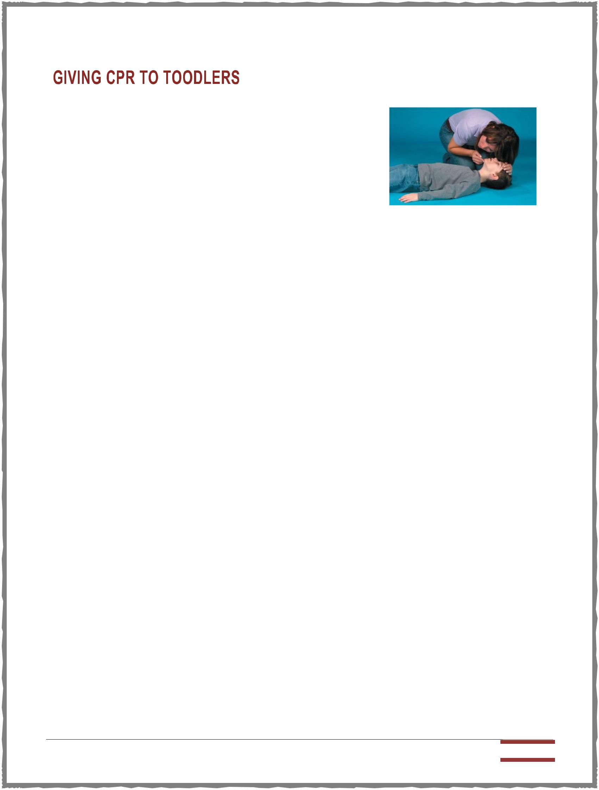

Choking can be fatal and a doctor is your first recourse in such a situation. Call 911 or your local emergency number before you do anything else. Obviously in a life-threatening emergency, you don't want to be reading information off the web. That's why every parent should get choking and CPR training at their local hospital. However, if you were to find yourself in this situation without a doctor or emergency facilities, here is how you can give CPR (cardiopulmonary resuscitation) to the choking toddler.

* Place the toddler on a flat surface, face upwards.
* Cover the toddler's mouth with your mouth and blow in air two times. Each breath should take only one second.
* Support the head and neck with one hand and thrust the chest thirty times-be firm yet gentle as children's bones can snap easily.
* Continuously repeat the cycle of two breaths and thirty presses.
* The toddler should start breathing after four or five of such attempts.
* Whether or not the child starts breathing, get medical help as soon as possible.

**Here is how to give correct chest thrusts:**

* Press two or three fingers of your free hand to push on the breastbone.
* Apply pressure to the chest thirty times at the speed of hundred thrusts per minute.
* The thrust should take the chest at least to half or one third of the depth of the toddlers chest.

CPR can be given by one or by two persons. In there are two persons giving CPR, one person will press the chest and the other person will blow air into the mouth. Both actions should not be done at the same time. When one person blows air the other person should stop thrusting the chest and vice versa.

Obviously, in a life-threatening emergency, you don't want to be reading information off the web. That's why every parent should get choking and CPR training at their local hospital.

Paul Banas is a founder of GreatDad.com. He writes articles on parenting styles, parenting, pregnancy and dads, parenting tips, baby names, parents without partners and many more topics related to dads.

My Survival Alliance | Volume #4 | Issue #6 Page: 3 



Dogs love to explore their environment with their mouths and this can sometimes get them into trouble. Due to their innate curiosity and indiscriminate eating habits, dogs can get things stuck in their mouths and throats. When a foreign object becomes lodged in a dog's airway, this becomes an emergency situation that must be dealt with immediately if the dog is to survive.

Severe allergic reactions can also cause throat swelling that may obstruct a dog's air passage. Dogs can also strangle themselves when their collars become snagged on something or when they jump a fence while tied to a leash (this is why you should never leave a dog unattended while attached to a leash). Choke chains can also result in strangulation and choking.

Signs that a dog may be choking include gagging, drooling, difficulty breathing and swallowing, anxiety, restlessness and pawing at the face. If you suspect your dog is choking you should take him to the vet immediately for emergency care.

There are some things you can do at home if your dog seems to be choking from a foreign object lodged in the throat. Gently open the dog's mouth and try to look inside to see if you can find anything that shouldn't be there. Feel around with your fingers to see if you can feel anything lodged in the mouth or throat. Dog's throats contain small bones that hold the base of the tongue which could be mistaken for a foreign object so be very careful not to try to remove something unless you can see it clearly.

If you're unable to find or remove the offending object you can help dislodge it by holding a small dog suspended with his head pointed downwards. For larger dogs lift the hind legs until the head is tilted downwards. Delivering a sharp tap with the flat of your hand between the dog's shoulder blades may succeed in dislodging the object.

A dog version of the Heimlich maneuver can also be attempted. Hold the dog by the waist with his rear end towards you and place a fist right behind the ribcage. Perform fast compresses on the abdomen 3 to 5 times and check to see if the foreign object has become dislodged.

Even if you succeed in removing any object that has become lodged in your

dog's throat you should make a visit to the vet, there could be an internal injury that needs to be addressed.

My Survival Alliance | Volume #4 | Issue #6 Page: 4 

People get into different emergencies that are unexpected. One person can be walking happily on the street and one minute they get stabbed at the back. Some are happily grilling outside their homes when suddenly rushed to find a remedy for their scalds. A person eating happily chunks of meat can instantly lose consciousness. No matter how we try to prevent it, there will always be people that are victims of emergencies. As a layman, we should know how to act in these situations even in non-medical ways.

**Burns:** According to American Burn Association,burn causes percentage belongs mostly to fire and flame which 46%. Second in line is caused by scalds garnering a percentage of 32% and 8% belong to hot object contact. There are 3,500 deaths attributed to Burns cases. Therefore, people should know how to put out fire in cases that someone catches it. If you are in flame, follow the stop, drop and roll technique to put out the fire. If your friend is on flames, try to find a fire blanket (may be a cloth dampened with water) to cover the person and use it with the technique mentioned to put out the fire effectively. After which, you can call paramedics to assist you in bringing the victim to the hospital. In terms of scalds, run water over it. If there are skins burned, do not remove it. You can try covering it with dampened clean cloth and transport immediately to the hospital.

**Choking:** This problem is caused when eating toofast or if you swallow food in big portions. This can cause blockage to the throat, causing the victim to gasp for air. Universal sign of choking is a person holding his neck. If the person is able to cough, all you have to do is to give support while the person is coughing. However, if the person loses consciousness it is time to do the Heimlich maneuver.

**Poisoning:** This is one of the emergencies athome especially when you have kids. The first thing you need to do is to identify what caused the poisoning. You have to do this to know whether they are corrosive or not. If it is corrosive, you need to call for help because there are things for the victim to take to neutralize the ingested poison before it can be eliminated in the body. If it is not corrosive, you can try to induce vomiting if the victim is slightly awake.



**Wounds:** These happen when the skin breakscaused by sharp blunt or any object. It can induce bleeding that can be visible or not. If bleeding occurs visibly, the best way to tackle the problem is control the bleeding with pressure. If wound is small and manageable, wash it with soap and water; then put some antiseptic solution on it.

There are no special gadgets needed in first aid. You can make do with anything you have at home. Fire blankets may be just a dampened clean cloth. A way to control bleeding may be made out of any material that is clean and absorbent. When it comes to wounds, it is important to have a first aid kit at home. In case of poisoning, it can be prevented as simple as putting all substances that are toxic hidden in the right place.

Having specialized in the fire blankets [http://www.essentialfiresafety.co.uk/] trade for over 20 years, Brian now works tirelessly to promote affordable fire safety for home and for business.

My Survival Alliance | Volume #4 | Issue #6 Page: 5 